**UCS802 COMPILER CONSTRUCTION LAB ASSIGNMENT 2**

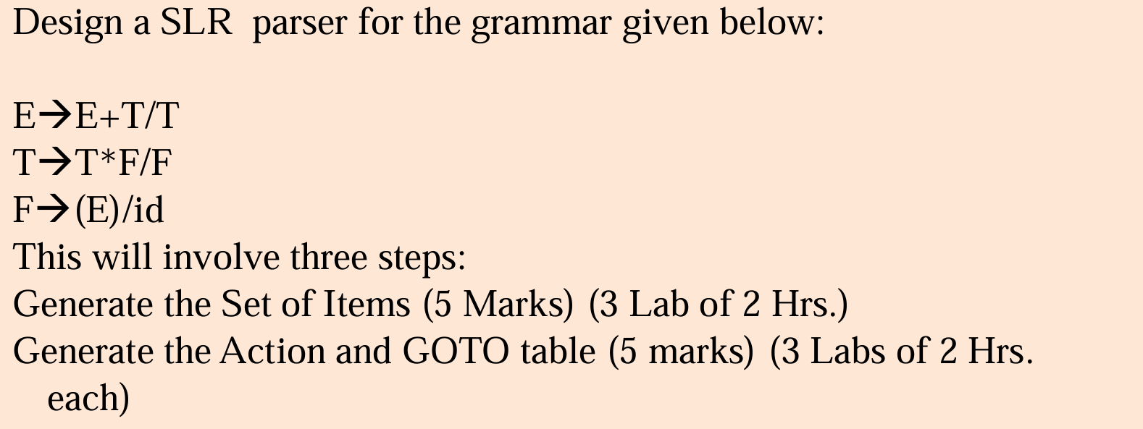

**Code to Check if Given Production Rules will go through the SLR(1) Parser**

Output will contain:

* The set of items generated during parsing
* Action Table
* Goto table
* If the production rule is accepted or rejected

import copy  
  
def grammarAugmentation(rules, nonterm_userdef,  
 start_symbol):  
 # newRules stores processed output rules  
 newRules = []  
  
 # create unique 'symbol' to  
 # - represent new start symbol  
 newChar = start_symbol + "'"  
 while (newChar in nonterm_userdef):  
 newChar += "'"  
  
 # adding rule to bring start symbol to RHS  
 newRules.append([newChar,  
 ['.', start_symbol]])  
  
 # new format => [LHS,[.RHS]],  
 # can't use dictionary since  
 # - duplicate keys can be there  
 for rule in rules:  
   
 # split LHS from RHS  
 k = rule.split("->")  
 lhs = k[0].strip()  
 rhs = k[1].strip()  
   
 # split all rule at '|'  
 # keep single derivation in one rule  
 multirhs = rhs.split('|')  
 for rhs1 in multirhs:  
 rhs1 = rhs1.strip().split()  
   
 # ADD dot pointer at start of RHS  
 rhs1.insert(0, '.')  
 newRules.append([lhs, rhs1])  
 return newRules  
  
  
# find closure  
def findClosure(input_state, dotSymbol):  
 global start_symbol, \  
 separatedRulesList, \  
 statesDict  
  
 # closureSet stores processed output  
 closureSet = []  
 if dotSymbol == start_symbol:  
 for rule in separatedRulesList:  
 if rule[0] == dotSymbol:  
 closureSet.append(rule)  
 else:  
 closureSet = input_state  
  
 prevLen = -1  
 while prevLen != len(closureSet):  
 prevLen = len(closureSet)  
  
 # "tempClosureSet" - used to eliminate  
 # concurrent modification error  
 tempClosureSet = []  
  
 # if dot pointing at new symbol,  
 # add corresponding rules to tempClosure  
 for rule in closureSet:  
 indexOfDot = rule[1].index('.')  
 if rule[1][-1] != '.':  
 dotPointsHere = rule[1][indexOfDot + 1]  
 for in_rule in separatedRulesList:  
 if dotPointsHere == in_rule[0] and \  
 in_rule not in tempClosureSet:  
 tempClosureSet.append(in_rule)  
  
 # add new closure rules to closureSet  
 for rule in tempClosureSet:  
 if rule not in closureSet:  
 closureSet.append(rule)  
 return closureSet  
  
  
def compute_GOTO(state):  
 global statesDict, stateCount  
  
 # find all symbols on which we need to  
 # make function call - GOTO  
 generateStatesFor = []  
 for rule in statesDict[state]:  
 # if rule is not "Handle"  
 if rule[1][-1] != '.':  
 indexOfDot = rule[1].index('.')  
 dotPointsHere = rule[1][indexOfDot + 1]  
 if dotPointsHere not in generateStatesFor:  
 generateStatesFor.append(dotPointsHere)  
  
 # call GOTO iteratively on all symbols pointed by dot  
 if len(generateStatesFor) != 0:  
 for symbol in generateStatesFor:  
 GOTO(state, symbol)  
 return  
  
  
def GOTO(state, charNextToDot):  
 global statesDict, stateCount, stateMap  
  
 # newState - stores processed new state  
 newState = []  
 for rule in statesDict[state]:  
 indexOfDot = rule[1].index('.')  
 if rule[1][-1] != '.':  
 if rule[1][indexOfDot + 1] == \  
 charNextToDot:  
 # swapping element with dot,  
 # to perform shift operation  
 shiftedRule = copy.deepcopy(rule)  
 shiftedRule[1][indexOfDot] = \  
 shiftedRule[1][indexOfDot + 1]  
 shiftedRule[1][indexOfDot + 1] = '.'  
 newState.append(shiftedRule)  
  
 addClosureRules = []  
 for rule in newState:  
 indexDot = rule[1].index('.')  
 # check that rule is not "Handle"  
 if rule[1][-1] != '.':  
 closureRes = \  
 findClosure(newState, rule[1][indexDot + 1])  
 for rule in closureRes:  
 if rule not in addClosureRules \  
 and rule not in newState:  
 addClosureRules.append(rule)  
  
 # add closure result to newState  
 for rule in addClosureRules:  
 newState.append(rule)  
  
 # find if newState already present  
 # in Dictionary  
 stateExists = -1  
 for state_num in statesDict:  
 if statesDict[state_num] == newState:  
 stateExists = state_num  
 break  
  
 # stateMap is a mapping of GOTO with  
 # its output states  
 if stateExists == -1:  
   
 # if newState is not in dictionary,  
 # then create new state  
 stateCount += 1  
 statesDict[stateCount] = newState  
 stateMap[(state, charNextToDot)] = stateCount  
 else:  
   
 # if state repetition found,  
 # assign that previous state number  
 stateMap[(state, charNextToDot)] = stateExists  
 return  
  
  
def generateStates(statesDict):  
 prev_len = -1  
 called_GOTO_on = []  
  
 # run loop till new states are getting added  
 while (len(statesDict) != prev_len):  
 prev_len = len(statesDict)  
 keys = list(statesDict.keys())  
  
 # make compute_GOTO function call  
 # on all states in dictionary  
 for key in keys:  
 if key not in called_GOTO_on:  
 called_GOTO_on.append(key)  
 compute_GOTO(key)  
 return  
  
# calculation of first  
# epsilon is denoted by '#' (semi-colon)  
  
# pass rule in first function  
def first(rule):  
 global rules, nonterm_userdef, \  
 term_userdef, diction, firsts  
   
 # recursion base condition  
 # (for terminal or epsilon)  
 if len(rule) != 0 and (rule is not None):  
 if rule[0] in term_userdef:  
 return rule[0]  
 elif rule[0] == '#':  
 return '#'  
  
 # condition for Non-Terminals  
 if len(rule) != 0:  
 if rule[0] in list(diction.keys()):  
   
 # fres temporary list of result  
 fres = []  
 rhs_rules = diction[rule[0]]  
   
 # call first on each rule of RHS  
 # fetched (& take union)  
 for itr in rhs_rules:  
 indivRes = first(itr)  
 if type(indivRes) is list:  
 for i in indivRes:  
 fres.append(i)  
 else:  
 fres.append(indivRes)  
  
 # if no epsilon in result  
 # - received return fres  
 if '#' not in fres:  
 return fres  
 else:  
   
 # apply epsilon  
 # rule => f(ABC)=f(A)-{e} U f(BC)  
 newList = []  
 fres.remove('#')  
 if len(rule) > 1:  
 ansNew = first(rule[1:])  
 if ansNew != None:  
 if type(ansNew) is list:  
 newList = fres + ansNew  
 else:  
 newList = fres + [ansNew]  
 else:  
 newList = fres  
 return newList  
 fres.append('#')  
 return fres  
  
  
# calculation of follow  
def follow(nt):  
 global start_symbol, rules, nonterm_userdef, \  
 term_userdef, diction, firsts, follows  
   
 # for start symbol return $ (recursion base case)  
 solset = set()  
 if nt == start_symbol:  
 # return '$'  
 solset.add('$')  
  
 # check all occurrences  
 # solset - is result of computed 'follow' so far  
  
 # For input, check in all rules  
 for curNT in diction:  
 rhs = diction[curNT]  
   
 # go for all productions of NT  
 for subrule in rhs:  
 if nt in subrule:  
   
 # call for all occurrences on  
 # - non-terminal in subrule  
 while nt in subrule:  
 index_nt = subrule.index(nt)  
 subrule = subrule[index_nt + 1:]  
   
 # empty condition - call follow on LHS  
 if len(subrule) != 0:  
   
 # compute first if symbols on  
 # - RHS of target Non-Terminal exists  
 res = first(subrule)  
   
 # if epsilon in result apply rule  
 # - (A->aBX)- follow of -  
 # - follow(B)=(first(X)-{ep}) U follow(A)  
 if '#' in res:  
 newList = []  
 res.remove('#')  
 ansNew = follow(curNT)  
 if ansNew != None:  
 if type(ansNew) is list:  
 newList = res + ansNew  
 else:  
 newList = res + [ansNew]  
 else:  
 newList = res  
 res = newList  
 else:  
   
 # when nothing in RHS, go circular  
 # - and take follow of LHS  
 # only if (NT in LHS)!=curNT  
 if nt != curNT:  
 res = follow(curNT)  
  
 # add follow result in set form  
 if res is not None:  
 if type(res) is list:  
 for g in res:  
 solset.add(g)  
 else:  
 solset.add(res)  
 return list(solset)  
  
  
def createParseTable(statesDict, stateMap, T, NT, finalResult):  
 global separatedRulesList, diction  
  
 # create rows and cols  
 rows = list(statesDict.keys())  
 cols = T+['$']+NT  
  
 # create empty table  
 Table = []  
 tempRow = []  
 for y in range(len(cols)):  
 tempRow.append('')  
 for x in range(len(rows)):  
 Table.append(copy.deepcopy(tempRow))  
  
 # make shift and GOTO entries in table  
 for entry in stateMap:  
 state = entry[0]  
 symbol = entry[1]  
 # get index  
 a = rows.index(state)  
 b = cols.index(symbol)  
 if symbol in NT:  
 Table[a][b] = Table[a][b]\  
 + f"{stateMap[entry]} "  
 elif symbol in T:  
 Table[a][b] = Table[a][b]\  
 + f"S{stateMap[entry]} "  
  
 # start REDUCE procedure  
  
 # number the separated rules  
 numbered = {}  
 key_count = 0  
 for rule in separatedRulesList:  
 tempRule = copy.deepcopy(rule)  
 tempRule[1].remove('.')  
 numbered[key_count] = tempRule  
 key_count += 1  
  
 # start REDUCE procedure  
 # format for follow computation  
 addedR = f"{separatedRulesList[0][0]} -> " \  
 f"{separatedRulesList[0][1][1]}"  
 rules.insert(0, addedR)  
 for rule in rules:  
 k = rule.split("->")  
   
 # remove un-necessary spaces  
 k[0] = k[0].strip()  
 k[1] = k[1].strip()  
 rhs = k[1]  
 multirhs = rhs.split('|')  
   
 # remove un-necessary spaces  
 for i in range(len(multirhs)):  
 multirhs[i] = multirhs[i].strip()  
 multirhs[i] = multirhs[i].split()  
 diction[k[0]] = multirhs  
  
 # find 'handle' items and calculate follow.  
 for stateno in statesDict:  
 for rule in statesDict[stateno]:  
 if rule[1][-1] == '.':  
   
 # match the item  
 temp2 = copy.deepcopy(rule)  
 temp2[1].remove('.')  
 for key in numbered:  
 if numbered[key] == temp2:  
   
 # put Rn in those ACTION symbol columns,  
 # who are in the follow of  
 # LHS of current Item.  
 follow_result = follow(rule[0])  
 for col in follow_result:  
 index = cols.index(col)  
 if key == 0:  
 Table[stateno][index] = "Accept"  
 finalResult[0] = "ACCEPTED"   
 else:  
 Table[stateno][index] =\  
 Table[stateno][index]+f"R{key} "  
  
 # printing table  
 print("\n(III) SLR(1) PARSING TABLE:\n")  
 frmt = "{:>8}" * len(cols)  
 print(" ", frmt.format(*cols), "\n")  
 ptr = 0  
 j = 0  
 for y in Table:  
 frmt1 = "{:>8}" * len(y)  
 print(f"{{:>3}} {frmt1.format(*y)}"  
 .format('I'+str(j)))  
 j += 1  
  
def printResult(rules):  
 for rule in rules:  
 print(f"{rule[0]} ->"  
 f" {' '.join(rule[1])}")  
  
def printAllGOTO(diction):  
 for itr in diction:  
 print(f"GOTO ( I{itr[0]} ,"  
 f" {itr[1]} ) = I{stateMap[itr]}")  
  
  
# GIVEN PRODUCTION RULES  
rules = ["E -> E + T | T",  
 "T -> T * F | F",  
 "F -> ( E ) | id"  
 ]  
nonterm_userdef = ['E', 'T', 'F']  
term_userdef = ['id', '+', '*', '(', ')']  
start_symbol = nonterm_userdef[0]  
  
print("\nORIGINAL GRAMMAR INPUT:\n")  
for y in rules:  
 print(y)  
   
separatedRulesList = \  
 grammarAugmentation(rules,  
 nonterm_userdef,  
 start_symbol)  
  
# find closure  
start_symbol = separatedRulesList[0][0]  
#print("\nCalculated closure: I0\n")  
I0 = findClosure(0, start_symbol)  
#printResult(I0)  
  
# use statesDict to store the states  
# use stateMap to store GOTOs  
statesDict = {}  
stateMap = {}  
  
# add first state to statesDict  
# and maintain stateCount  
# - for newState generation  
statesDict[0] = I0  
stateCount = 0  
  
# computing states by GOTO  
generateStates(statesDict)  
  
# print goto states  
print("\n(I) STATES GENERATED: \n")  
for st in statesDict:  
 print(f"State = I{st}")  
 printResult(statesDict[st])  
 print()  
  
print("(II) RESULT AFTER GOTO:\n")  
printAllGOTO(stateMap)   
diction = {}  
  
finalResult = [""]  
  
# call createParseTable function  
createParseTable(statesDict, stateMap,  
 term_userdef,  
 nonterm_userdef, finalResult)  
   
if finalResult[0] == "ACCEPTED":  
 print("ACCEPTED")  
else:  
 print("REJECTED")

**Output:**

1. **Original Output:**

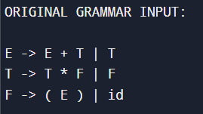

1. **States Generated:**

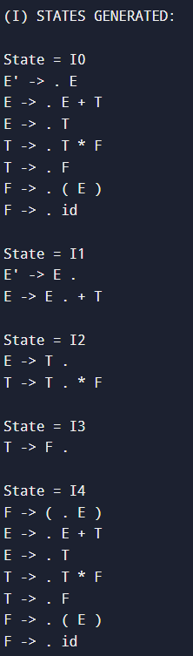 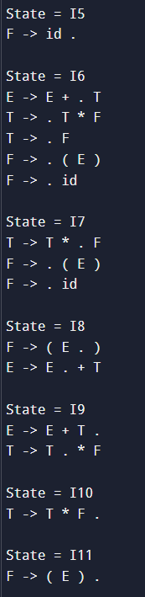

1. **Result after GOTO:**

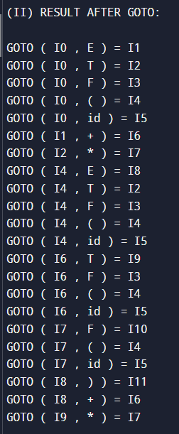

1. **Action Table:**

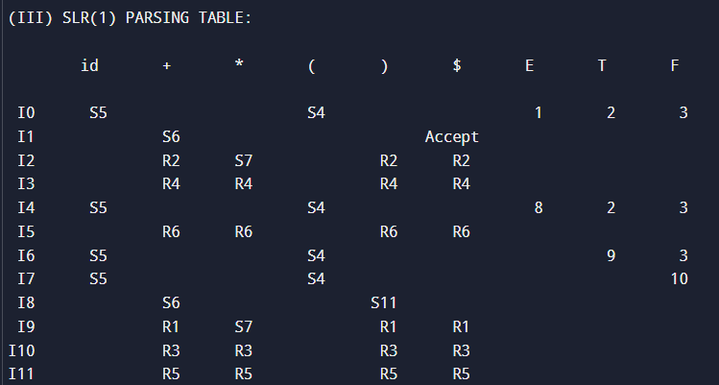

1. **Final Output: The given grammar is ACCEPTED**

